

**ChocAn User Manual**

Team 11

**Table of Contents**

1. Task Distribution 3
2. Program Overview 4
3. Main Menu 4

a. Provider Menu 5

1. Select Provider Directory 5
2. Validate Member 6
3. Bill ChocAn 6
4. 4.Log Out 8

b. Manager Menu 8

* + 1. Print Reports 8
    2. Run Main Accounting Procedure 11
    3. Log Out 11

c. Operator Menu 11

1. Run Interactive Mode 12
2. Log Out 12

|  |  |
| --- | --- |
| **Task Distribution** |  |
| Jacob Carney   * Reports * Member Reports, Provider Report, Manager Report * ANT * JavaDocs * Updated Class Diagram | **16.6%** |
| Shelby Deerman   * Provider Directory * BillingInfo * Updated Sequence Diagrams | **16.6%** |
| Eleri Floyd   * Operator Menu * Manager Menu * Provider Files * Member Files | **16.6%** |
| Ryan Moddesette   * EFTReport * Member * Provider * Service Member | **16.6%** |
| Summer Davis   * Main Menu * Provider Menu * Hash Map Intialize * User Manual | **16.6%** |
| Rediat Shamsu   * Disk * EFTReport * Service Provider | **16.6%** |

**Program Overview**

Chocoholics Anonymous is an organization committed to helping people who are addicted to chocolate. The program is for Managers, Providers, and Members of the system to apply services and maintain sales between Members and Providers, allowing Managers to oversee the operations.

**Main Menu**

When the program begins, it opens to a menu where you must enter your email or enter “Quit” to exit the system. Next, Menu will ask you to enter your password (cannot be less than 8 characters, must contain an uppercase letter & special character). After valid password is entered, you must enter your position/occupation from the following: Provider = 1, Manager = 2, Operator = 3.

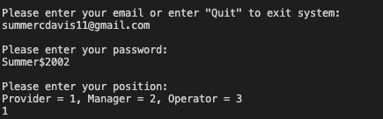

**Provider Menu**

Once the user enters Provider Menu, you must enter your provider number (must be 9 digits). Afterwards, the Provider Menu will give you the following selections: **1. Select Provider Directory, 2. Validate Member, 3. Bill ChocAn, 4. Log Out.** You must choose one of the following options above.

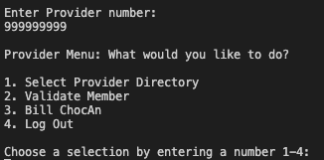

1. **Provider Directory**

If selection in Provider Menu is 1, it will open “ProviderDirectory.txt” displaying the various service names, along with their service codes and fees.

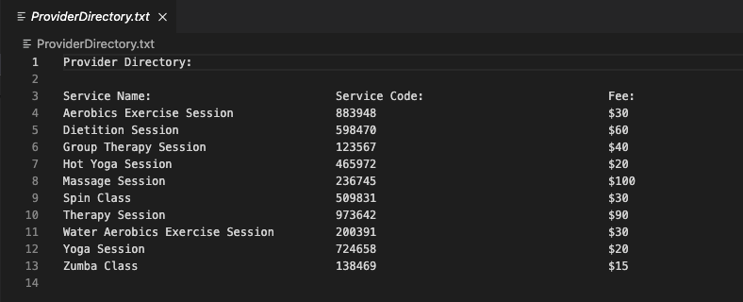

1. **Validate Member**

If selection in Provider Menu is 2, the system will prompt you to enter in member number. Once member number is entered, the system will either display “Validated”, “Member Suspended”, or “Invalid Number. Member not found.”

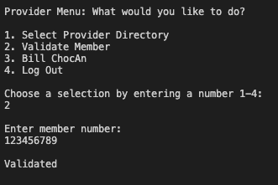

1. **Bill ChocAn**

If selection in Provider Menu is 3, you will be prompted to enter member number. Once member number is entered, it will display member status. Next, it will ask you to enter date of service(MM-DD-YYYY). Next, it will display the Provider Directory. Next, it will prompt you to enter the service code. After the correct service code is entered, it will show the service corresponding to the service code you entered. It will ask you to verify the service code entered is correct. Next, it will prompt you to enter comments about the service and display the fee. Afterwards, it will display the Verification Form where it will prompt the user to “Enter Date of Service” (MM-DD-YYYY). Then, it will ask you to “Enter Member Number” and “Member Name” again.

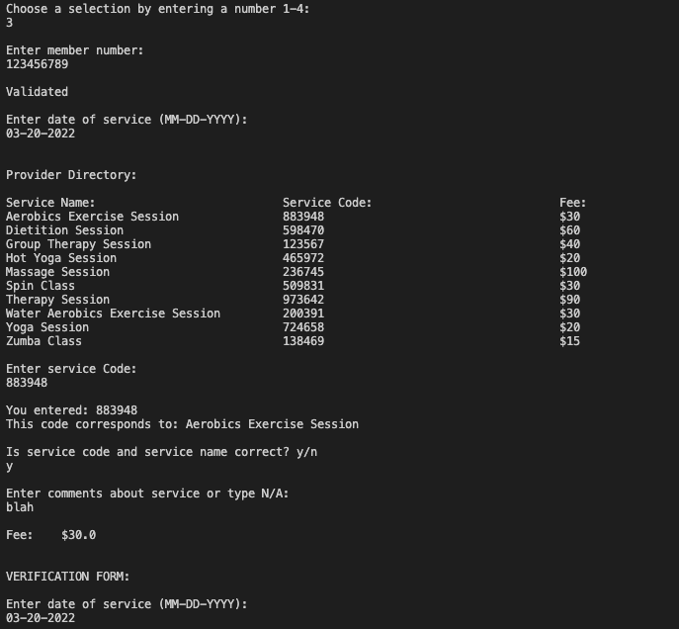

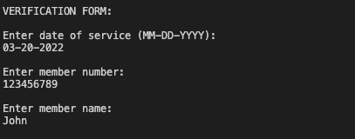

1. **Log Out**

If you select 4 in Provider Menu, the system will bring you back to the Main Menu, where it will prompt you to enter your email address again.

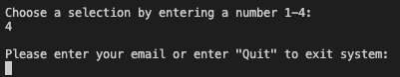

**Manager Menu**

Once the user enters the Manager Menu, the menu will display the following selections: **1. Print Reports**, **2. Run main accounting procedure**, **3. Log Out.** You will be able to select one of these options.

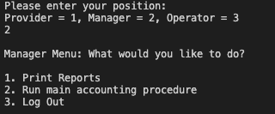

1. **Print Reports**

Once you select option 1, “Print Reports” in Manager Menu, the system will then ask you to select what type of report you want to print. It will display the following options: 1: Member, 2: Provider , 3: Manager.

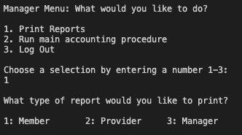

1. **Member Report**

Once you select 1, for Member Report, the system will prompt you to “Enter member number of member you would like to view.” Once you enter member number, it will print out the Member Report corresponding to the member number you entered.

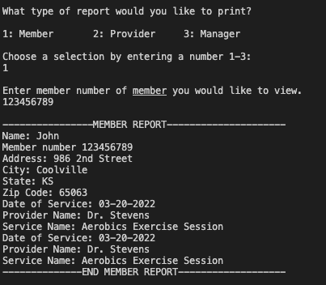

1. **Provider Report**

Once you select 2, for Provider Report, the system will prompt you to “Enter provider number of provider you would like to view.” Once you enter member number, it will print out the Provider Report corresponding to the member number you entered.

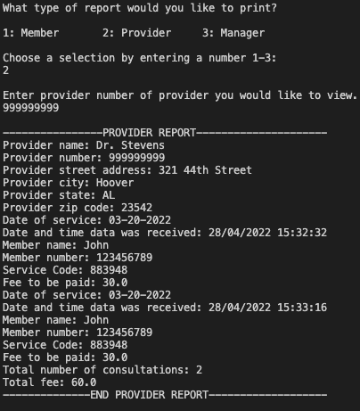

1. **Manager Report**

Once you select 3, for Manger Report, the system will follow the same instructions for Member and Provider Report.

1. **Run Main Accounting Procedure**

Once you select 2 for “Run Main Accounting Procedure” the system reads the week’s file of services provided and prints a number of reports.

1. **Log Out**

If you select 3 in Manager Menu, the system will bring you back to the Main Menu, where it will prompt you to enter your email address again.

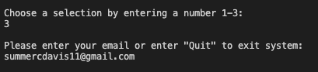

**Operator Menu**

Once the user enters the Operator Menu, the menu will display the following selections: 1. Run Interactive Mode and 2. Log Out. You will be able to select one of these options.

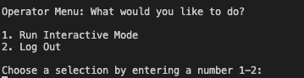

1. **Run Interactive Mode**

Once you select Run Interactive Mode, you will be prompted to select an action from the following: 1: Add Provider, 2: Remove Provider, 3: Edit Provider, 4: Add Member, 5: Remove Member, 6: Edit Member.

Example of Add Provider:

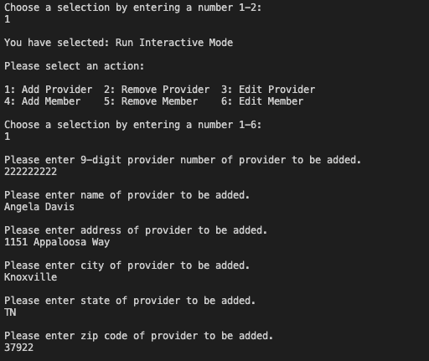

1. **Log Out**

If you select 2 in Operator Menu, the system will bring you back to the Main Menu, where it will prompt you to enter your email address again.

